**OntimeFlightPerformance**

1. **Data Setup in HDFS**

**Step 1: Copy the provided csv files in a directory named AirlinesOntimeAnalysis**

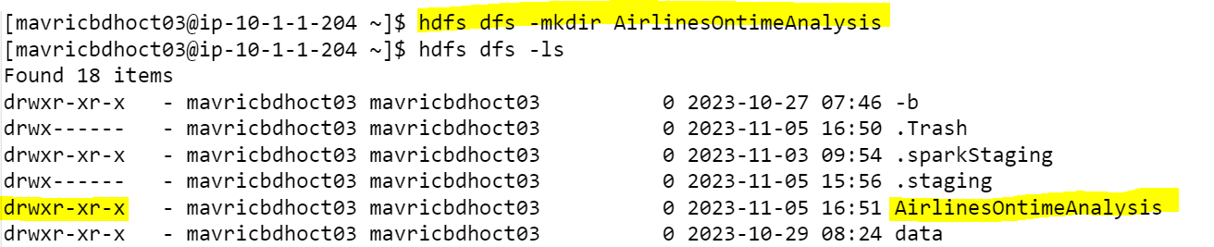

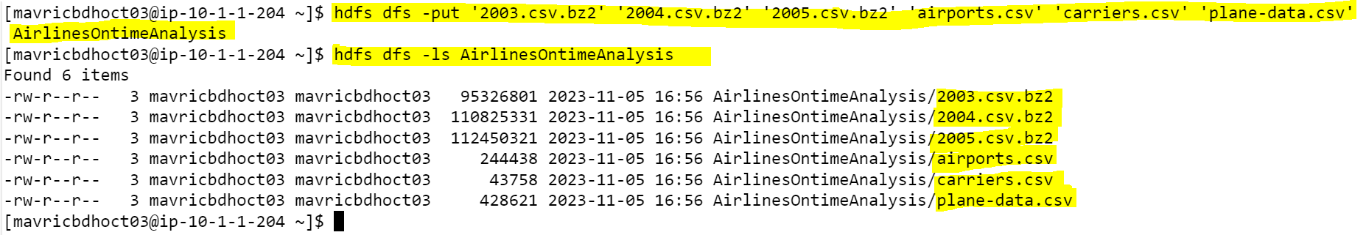

**Step 2: Unzip the contents for the bz2 files.**





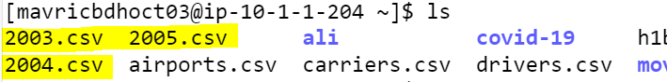

**Step 3: Create the directories in hdfs where your data will reside.**

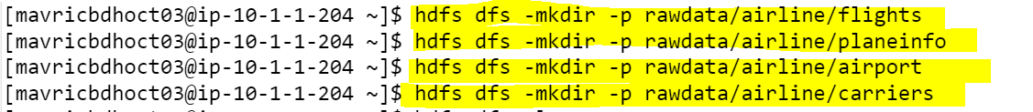

**Step 4: copy the respective files to the above created hdfs structure.**





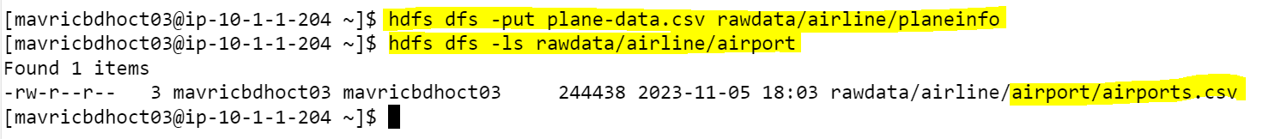

1. **Create tables using Hive.**

**Airport**

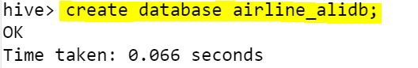



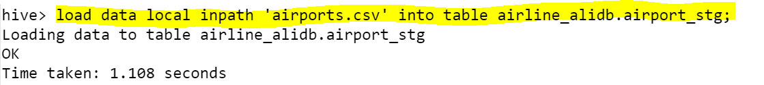

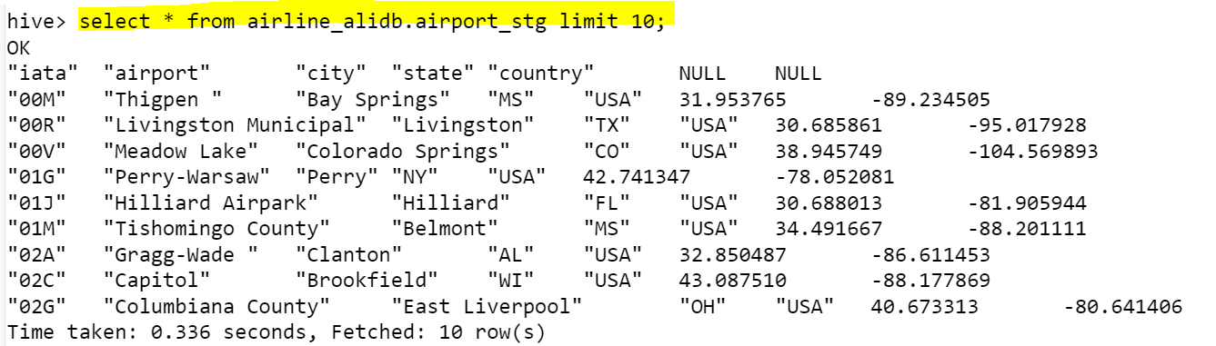

**Carriers**





**Plane Info**







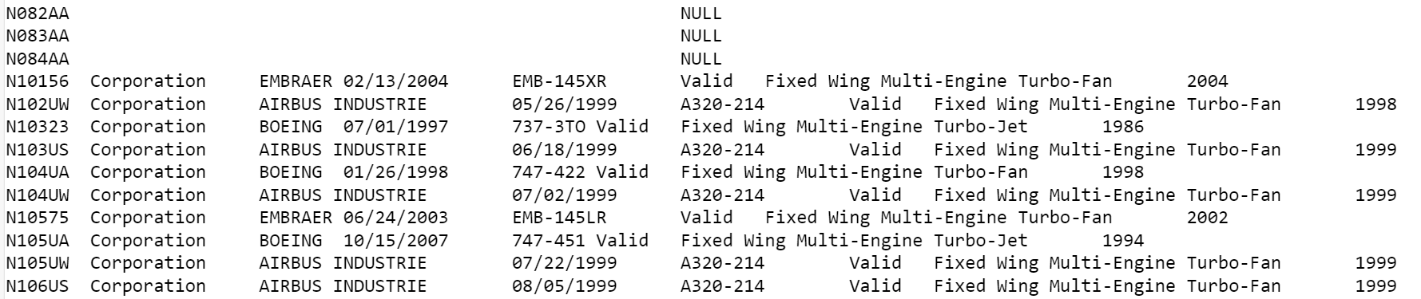

**Flights**

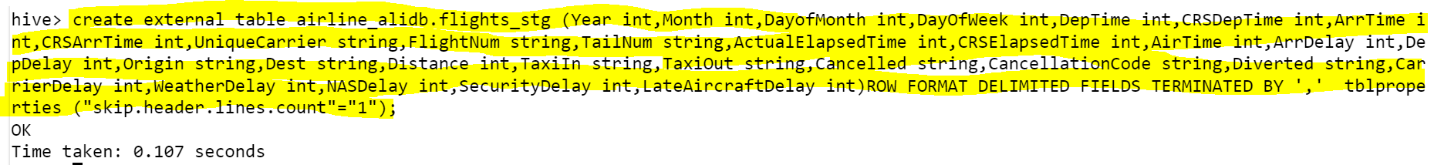

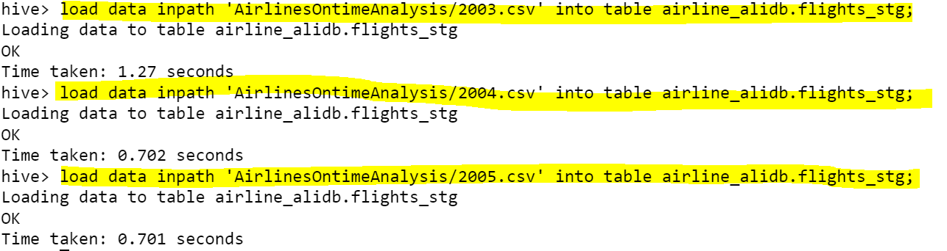

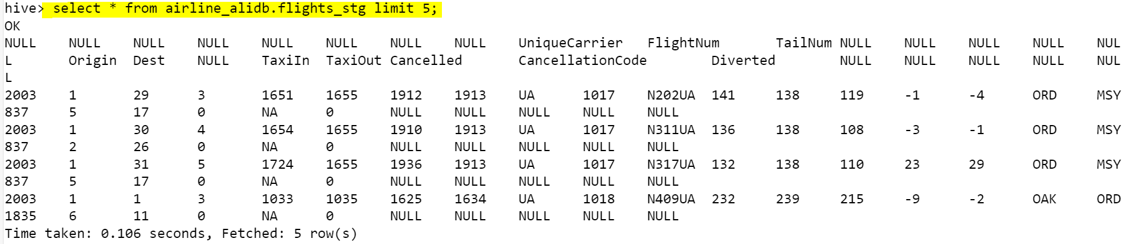

**What is the average arrival delay and average departure delay in each month of the year 2004?**

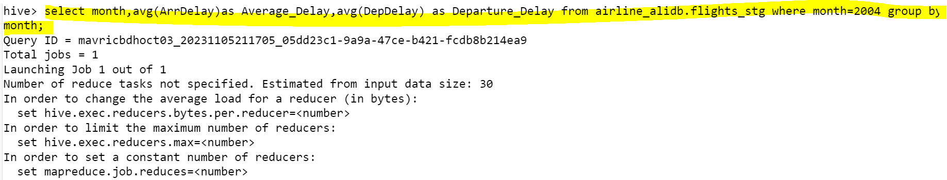

1. **Improving the performance of Hive tables - Parquet format.**

